**SQL Assignment**

**(Solution for SQL ISLAND game)**

Data tables available:

* **VILLAGE (villageid, name, chief)**

SELECT * FROM village

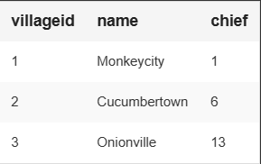

* **INHABITANT (personid, name, villageid, gender, job, gold, state)**

SELECT * FROM inhabitant

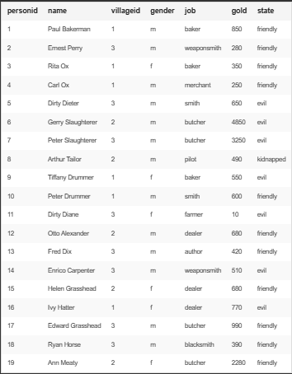

* **ITEM (item, owner)**

SELECT * FROM item

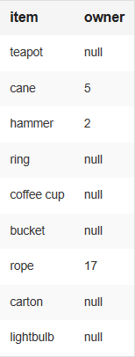

Some important Queries used in the process of the game:

1. 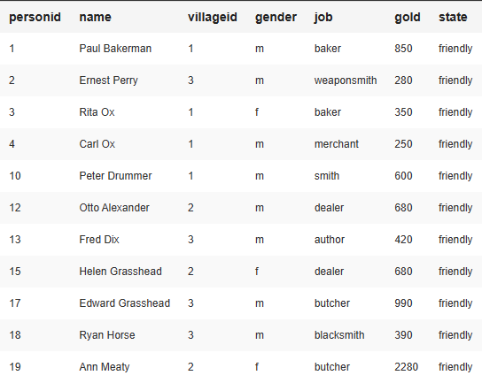SELECT * FROM inhabitant WHERE state="friendly"
2. SELECT * FROM inhabitant WHERE state="friendly" AND job LIKE "%smith"

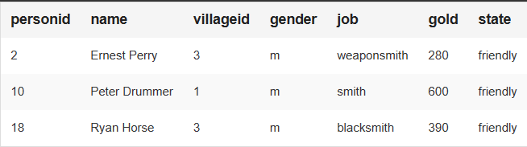

1. INSERT INTO inhabitant (name, villageid, gender, job, gold, state) VALUES ('Stranger', 1, '?', '?', 0, '?')

-Inserts new values of data into the existing data list as a new entry.

1. SELECT personid FROM inhabitant WHERE name="Stranger"

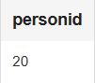

1. SELECT gold FROM inhabitant WHERE name="Stranger"

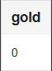

1. SELECT * FROM item WHERE owner IS NULL

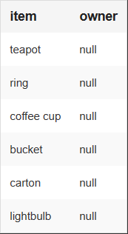

1. UPDATE item SET owner = 20 WHERE owner IS NULL

-Changes values of the column from “null” to “20”

1. SELECT * FROM item WHERE owner="20"

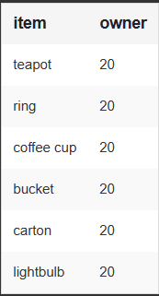

1. SELECT * FROM inhabitant WHERE state="friendly" AND job="dealer" OR job="merchant"

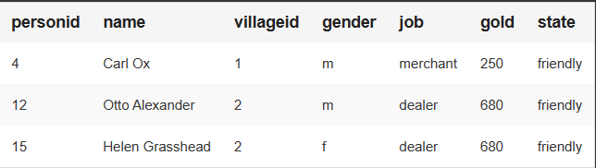

1. UPDATE inhabitant SET name = "Zack" WHERE personid=20

-Changes value in name column to “Zack” for the entry with personid “20”

1. SELECT * FROM inhabitant WHERE job="baker" ORDER BY gold DESC

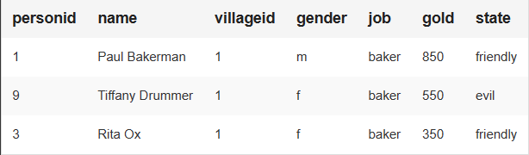

1. SELECT * FROM inhabitant WHERE job="pilot"

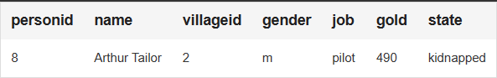

1. SELECT village.name FROM village LEFT JOIN inhabitant WHERE village.villageid = inhabitant.villageid AND inhabitant.name = 'Dirty Dieter'

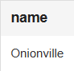

1. SELECT inhabitant.name FROM inhabitant LEFT JOIN village WHERE village.chief = inhabitant.personid AND village.name ="Onionville"

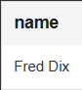

1. SELECT COUNT (*) FROM inhabitant LEFT JOIN village WHERE village.villageid = inhabitant.villageid AND village.name ="Onionville" AND gender="f"

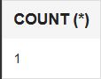

1. SELECT inhabitant.name FROM inhabitant LEFT JOIN village WHERE village.villageid = inhabitant.villageid AND village.name ="Onionville" AND gender="f"

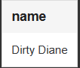

1. SELECT SUM(inhabitant.gold) FROM inhabitant LEFT JOIN village WHERE village.villageid = inhabitant.villageid AND village.name = 'Cucumbertown'

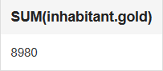

1. SELECT SUM(inhabitant.gold) FROM inhabitant WHERE job = “baker” OR job = “dealer” OR job = “merchant”
2. SELECT * FROM inhabitant LEFT JOIN item WHERE item.owner = inhabitant.personid AND item.owner = 20

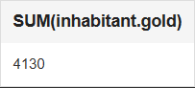

1. SELECT job, SUM(inhabitant.gold), AVG(inhabitant.gold) FROM inhabitant GROUP BY job ORDER BY AVG(inhabitant.gold)

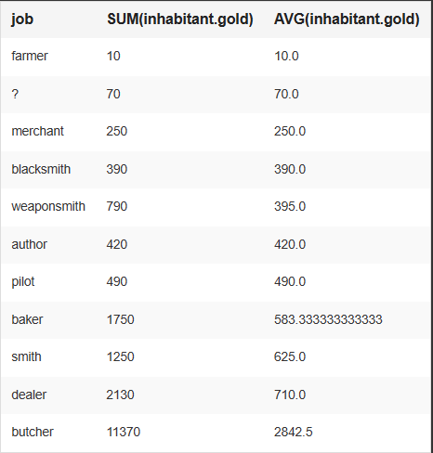

1. SELECT state, AVG(inhabitant.gold) FROM inhabitant GROUP BY state ORDER BY AVG(inhabitant.gold)

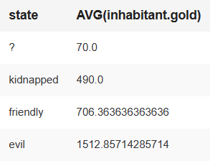

1. DELETE FROM inhabitant WHERE name = 'Dirty Dieter'

* “Kills” the kidnapper by removing him from existence, deleting his entry from the table.

1. DELETE FROM inhabitant WHERE name = "Dirty Diane"

* “Kills” the kidnapper’s sister by removing her too from existence, deleting her entry from the table.

1. UPDATE inhabitant SET state = "friendly" WHERE state = "kidnapped”

* Changes state column from “kidnapped” to “friendly”, freeing the pilot.